Adding thread group to the test plan

Then adding test sampler to the thread group.

Then adding number thread count is 100

And ramp is 5

And loop 1

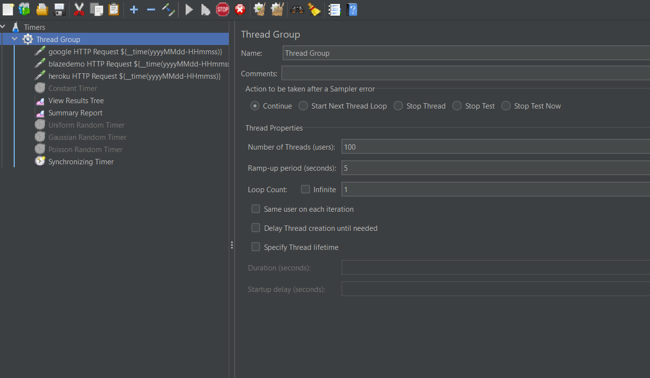

Then adding synchronizing timer to the thread group

Then number of simulates users to group by 10

Timeout-0

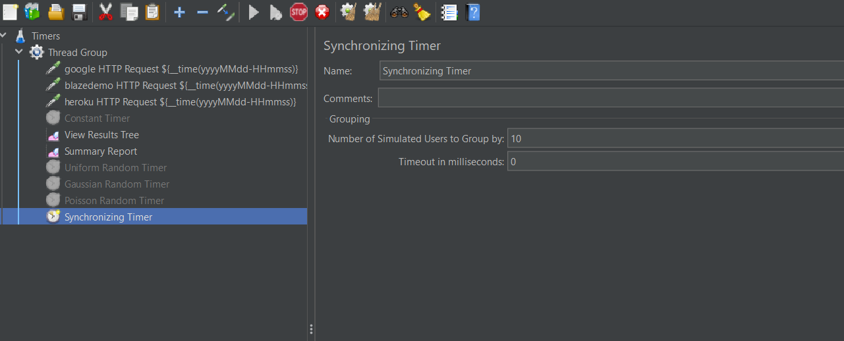

Click on run button to view the result